Language Education in Multilingual Switzerland and Belgium

Author: Medea Leonardi

27 January 2021

Short description

This blog entry focuses on language education policies in both Belgium and Switzerland and investigates them in connection to the advancement of globalization as well as national cultural identity.

Linguistic situation in Switzerland and Belgium

Belgium and Switzerland are the two major multilingual countries in Europe and as such, they share some upsides as well as challenges. However, their socio-political stories of multilingualism are dissimilar in many respects. The two nations have had and still have not only different conceptions of the official languages within their national boundaries, but also divergent approaches to the management of language education. While Belgium has a “long history of conflict” behind itself (Kuzelewska 2015: 1), Switzerland has a more pacific socio-linguistic past. The dissimilarity of the two countries’ backgrounds is reflected in the way multilingualism is perceived: if Belgium is closer to a case of an internally divided nation, Switzerland is distinguished by its “unity-in-diversity”. The confederation’s ability to be a united nation despite profound cultural and linguistic differences led it to be referred to as a Willensnation - “nation of the will” (Stepkowska 2019: 70).
Nowadays, Belgium has officially three languages: French in the south, Dutch in the north – respectively Wallonia and the Flanders – and German in the east. Official multilingualism distinguishes the Brussels capital region, where French and Dutch are both official. [Figure 1] shows the distribution of the different language regions in Belgium.

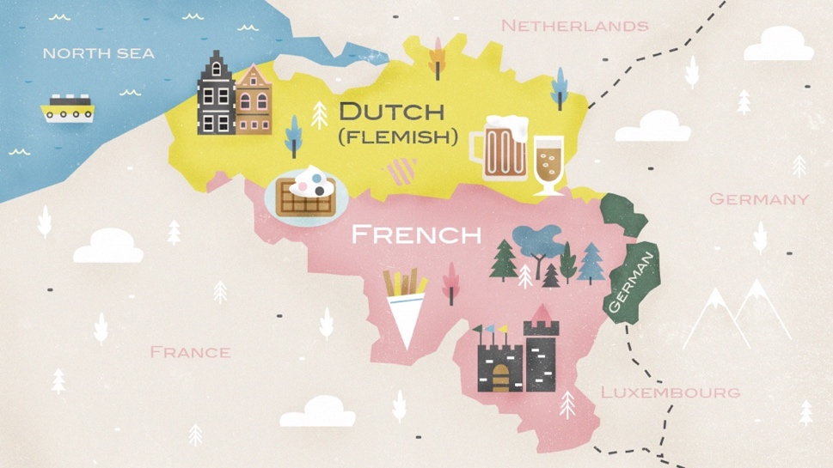
[Figure 1] Linguistic regions of Belgium

Switzerland, in turn, has four national languages, where, in terms of proportions, German dominates, followed by French, Italian and Romansch. [Figure 2] exposes the four Swiss linguistic areas.

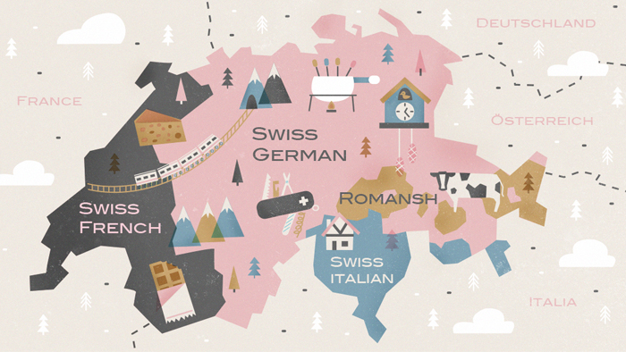
[Figure 2] Linguistic regions of Switzerland

As plurilingual countries, both Belgium and Switzerland have had to adopt some strategies which allowed them to manage such variety taking into account all regions and limiting any kind of minority discrimination. In this perspective, both countries have adopted the so-called “principle of territoriality”, which constitutes a system of political subsidiarity that delegates to the single cantons authority over some matters, including the freedom to decide the official language of the area. Thus, the communities hold the power to decide not only which language should be spoken on the territory, but also which ones should be taught in school and how. As far as Belgium is concerned, such principle has been particularly helpful in the pacifying process between the Flemish and the French regions. The tension between the two communities is in fact marked by the strong tendency of French to impose itself for the linguistic hegemony of the country, even though it only constitutes a minority (59,6 % of the Belgian population, in fact, speaks Dutch, while only 40% speaks French). As mentioned, the territoriality principle guarantees the decisional freedom of the regions – and in the case of Switzerland, the cantons – in many fields, including education. As a result, the single educational systems of communities and cantons – respectively in Belgium and Switzerland – differ from one another.
In the last few years there has been a long debate on the languages that the school system in both countries should adopt, in which the globalization certainly played a central role. The raising of a new, global economy has in fact turned language knowledge – especially of English – into a market asset (Stotz 2006). Nevertheless, cultural reasons also constitute a relevant element in the debate, since they situate themselves at the polar opposite of the more profit-based views, which would rather prioritize English as a foreign language. At this point, a central question should be raised: what is the conceptions and management of multilingualism through educational policies concerning foreign language learning in Switzerland and Belgium? But also, we should question whether the growing success of English is in any way affecting the countries multiculturalism.

The case of Belgium

As mentioned before, tensions and conflicts between French Wallonia and Dutch Flanders have characterized the socio-political and linguistic history of Belgium for a long period of time. In fact, until the 1930s, Dutch was still not officially recognized as the language of the Flanders (Kuzelewska 2015). Even though the majority of the inhabitants of the Flemish community spoke Dutch as their first language, before that time “French was used by upper classes and dominated education, administration, politics and public life” (Kuzelewska 2015: 4). In the same period, a law that officially split the country into four linguistic regions (Wallonia, Flanders, German part and Brussels) was introduced, followed by the adoption of the “territoriality principle”, after which schooling organizations separated completely. One of the sad consequences of such a clear-cut division, though, is a great “lack of knowledge of citizens about the other region” and a sort of “alienat[ion] from it” (Kuzelewska 2015: 7), since the contact between the different language communities grew minimal (Volg & Hüning 2010). However, the case of Brussels represents an exception. Even though the French and Dutch education systems in the capital are completely separate, parents can decide which school - either the French or the Dutch one - they would like their children to attend. Interestingly, because of the freedom to decide, many French-speaking pupils – following their parents’ wish – opt to attend Dutch schools. As a consequence, Brussels schools present high levels of heterogeneity, which constitutes a distinctive contact situation between youths of different communities (Mattewie & Van Mensel 2020).
The language related differences between the four communities’ education systems are mainly three: which foreign languages (FL) are taught, their number and the age at which they start to be learned (Mattewie & Van Mensel 2020). Being the smallest one in the country, the German speaking community can boast the highest number of foreign language classes (Mattewie & Van Mensel 2020), while Wallonia and the Flanders show more reluctant to learn the language of the “other”. Although nowadays French and Dutch are both considered official languages, a certain disparity between the two is still visible, given by the fact that while in the Flanders, French learning is compulsory, in Wallonia region Dutch is not an obligatory school subject (Volg & Hüning 2010). In francophone Wallonia, pupils’ learing of the first foreign language to learn (FL1) is in fact free both in primary and secondary school, while in Brussels, pupils’ FL1 is obligatorily Dutch, although they can still choose their second or third foreign language (FL2 and FL3) from English, Dutch and Spanish. The reluctance to learn Dutch does not only come from the fact that it is considered a difficult and unattractive language, but it also goes hand in hand with a turbulent socio-political past, which led to sometimes negative conceptions of the “other” (Deborsu & De Wit 2014).
The learning of Belgian national languages has been additionally hindered by the increasing role of English. As a matter of fact, both in Flanders and Brussels, the learning of English has lately been reinforced by reducing the hours of French. The success of English at the expense of Dutch in Wallonia is also increasing: pupils’ choice of English as FL1 is progressively growing in popularity and such shift can be explained, according to Mattewie and Van Mensel (2020), by the “growing importance of English in the new globalized world”. In fact, the growth of English acclaim among young generations is likely to be alimented by the new channels introduced by new technologies, whose networks are nowadays connecting the whole world, such as music, internet, social media and TV. The overbearing increase of English importance is felt to the point that it raised the option of putting Dutch as a compulsory FL1 in Wallonia (Mattewie & Van Mensel 2020).
In fact, the case of Belgium language education has given rise, especially in recent years, to a dialectic of opinions. As Hambye and Richards’s study (2012) highlights, in Belgian society there are mainly two contrasting discourses about multilingualism. The first one promotes the learning – and therefore the maintenance – of multiple languages and it is responding to the globalizing movement (which promotes English, especially at the expense of Dutch learning in Wallonia) as well as the cultural need of knowing the national languages. In fact, a good knowledge of different languages represents a fundamental asset in the new economy, since it permits an opening to the global market. As Hambye and Richards (2012: 163) state, “globalization movements”, that in the last few years have interconnected the whole world, “have modified the value and the forms of multilingualism in many western countries”, altering the priorities of language education and the hierarchy of the languages to be taught. Being strongly related to language learning, education is the area that is mostly supposed to form young generations and open them up to opportunities – mostly related to work chances – in the global market. In the new, globalized economy, individual multilingualism represents an essential tool as well as a market value. “Education is [thus] a place where the appeal of multilingualism and mobility is in tension with the more ‘protectionist’ role of the school”, which should aim to maintain local languages and guarantee their reproduction (Hambye & Richards 2012: 165).
The second approach to a multilingual society is more reticent and is characterized by a more conservationist view, which in fact sees multilingualism as “far from […] beneficial” (Hambye & Richards 2012: 173). The main reason for such reticence lies in the fear that the learning of other languages other than the mother tongue could hinder pupils’ good knowledge of the latter (Hambye & Richards 2012). It is interesting to note that despite being a multilingual nation, official bilingual school programs are not present in the country, which is probably a consequence of its socio-political past of tensions. Following a 1963 legislation, bilingual and multilingual education was not even allowed in Belgium (Mattewie & Van Mensel 2020). Nevertheless, although scarce, the CLIL (Content and Language Integrated Learning) programs are an example of education where some subjects are taught in a different language in order to enhance the language learning process. Such programs have been welcomed especially in Wallonia, while Flanders were more reluctant. As a matter of fact, in the Dutch Community just nine secondary schools have adopted CLIL programs - of which five have opted for English as the teaching language instead of French - while in Wallonia, this type of curriculum was introduced in schools not only on a secondary level, but also in pre-primary and primary education (Volg & Hüning 2010). Besides, those who follow CLIL schooling usually represent an elite, which goes hand in hand with the fact that the main reasons for which parents choose to sign up their children to such school programs is the quality of such institutions and the “professional benefits immersion could lead to” (Hambye & Richards 2012: 172). Notwithstanding, elite teenagers in the French speaking part of Belgium do not have that much knowledge of Dutch. Instead, they are well aware of being part of a “school elite” (Hambye & Richards 2012: 172), and therefore consider themselves superior, which helps compromising equality among young people.

The case of Switzerland

Switzerland is an example of nation where multilingualism paradoxically enhances the unity of the various language communities (Stepkovska 2019). In fact, differently from Belgium, language heterogeneity is one of the prides of the country, which constructs in multilingualism as a strength and a tool enhancing unity and peace. Being a country with four national languages and thus four distinct communities, national cohesion is assured by the forementioned principle of territoriality, just as in Belgium, which allows a great level of cantonal autonomy, including in education policies (Stotz 2006). The influence of Swiss federalism on the country’s language educational system is undoubtedly very strong (Brohy 2005), and when towards the end of the 1990s, the Conference of Cantonal Ministers of Education – which has the power to advance recommendations about the school curriculum – asked for the development of a national program of language learning, the suggested policy was the “obligation for all pupils to learn, beside L1, another national language, plus English, and the opportunity for all pupils to learn Italian as a third national language” (Brohy 2005: 138). However, the decision regarding which language to adopt as L2 (between the national language or English) was delegated to the cantons. The result was that “most German-speaking cantons chose English, the French speaking part decided to maintain German as L2, [while] Italian speaking Ticino introduced French, German and English” (Brohy 2005: 138). It is therefore already possible to notice the constant presence of English in all curricula, which has been the case for a long time. However, what has changed is that it was made compulsory everywhere. Again, a signal of its growing importance in the world. Further evidence of such phenomenon lies in the fact that the “new Ticino guidelines” have changed from making French compulsory and English non-mandatory, to the opposite policy, where “French gets optional in the 8th grade” (Brohy 2005: 143).
Thus, despite the renowned nationalism of Switzerland, which promotes the country’s cohesion, a language strife, very similar to that of Belgium, characterizes the current issue of national multilingualism. The different positions at the center of the debate are, also in this case, mainly two: those who want English to be taught as FL1 in primary schools, and those who, fight to prioritize the learning of the national languages as FL1 instead. The first discourse supports its idea by claiming that not only English is “linked to opportunity and popular choice”, but that there are also “direct financial benefits for employees mastering [it] in German-speaking Switzerland” (Stotz 2006: 256). It does not come as a surprise, in fact, that such idea is particularly evident in urban areas with “strongly export-oriented economies” (Stotz 2006: 256), as it is the case for Zurich. At the end of the 1990s, since “the pressure to introduce English as L2 got [increasingly] stronger” (Brohy 2005: 138), Zurich has advanced the project of introducing English “from the first grade of the primary school onwards”. The project was then approved and the result is that Zurich residents learn English before the second national language – French – which pupils start to learn only from the fifth year (Stotz 2006). This clearly signals the canton’s view of “linguistic resources as a commodity rather than a symbolic effort towards national cohesion” (Heller 2003). Cohesion that, instead, represents the priority of those who, in this language debate, do not agree. Indeed, the second discourse of the strife supports the learning of the national languages over English, whose increasing use is seen as a dangerous threat to Switzerland varied culture. The “resorting to English, a foreign language to all speakers” is regarded as an “an acknowledgement of failure”, since conforming to a single, non-national language would undermine the knowledge of the different regional cultures (Stotz 2006: 254) and therefore bring to a general flattening of the country’s culture, whose variety had been for a long time a source of national construction.
In addition to economic reasons, the threat of English is strongly linked to the fact that the majority of the young generation generally prefers to learn English instead of the other national languages, as confirmed the case of Zurich pupils of the 7th and 8th grade – learning French as a second FL and English as a third FL – who have stated to be “more interested in learning English than French” (Grin & Korth 2004: 74). Moreover, the learning of German is considered, by French and Italian speakers, little necessary. This idea is supported by the claim that Swiss-German speakers do not like communicating in standard German – since native Swiss Germans usually speak their own dialect – and rather opt for English when confronted with French or Italian speakers (Grin & Korth 2004). The idea that English is to be prioritized, however, is largely sustained by language attitudes, which make people think of English as easy to learn and more useful when communicating with people who do not share the same language. Nevertheless, this idea is not always true, as confirmed, for instance, by the fact that German and English are used more or less in the same amount by French speakers in the Romandie; or that in the German part of the country the employment of French is even higher than that of English (Grin & Korth 2004).
Finally, even though bilingual education in Switzerland, just as in Belgium, is quite a rare phenomenon, alternative methods of language learning emerged in the Confederation too, such as the aforementioned CLIL programs, which allows the increase of the hours of language English teaching, while at the same time not compromising the learning of the national languages (Grin & Korth 2004).

Conclusions
Multilingualism in Switzerland and Belgium is thus differently conceived and managed. However, the principle of territoriality, dividing the nation into different monolingual areas and giving them the power to decide what language to adopt as official, has been adopted by both countries in order to cope more easily with their linguistic heterogeneity. The regional division in Belgium has yet led to the alienation between the communities from the other, which has also been fostered by the turbulent socio-political background of the country, characterized by continuous tensions between the French and Dutch linguistic regions. But if Belgium’s multilingualism represents a cause of internal disunion, Switzerland makes of its diversity an economic and symbolic strength, which discursively enhances the cohesion of the nation and guarantees the peace between its linguistic regions. Swiss nationalism plays an important role in the country’s language education and has led to a mandatory learning of at least two national languages in each region. Nevertheless, Switzerland, like Belgium, is also being threatened by the overpowering advance of English, which is being used progressively more in the whole country and therefore puts pressure on the local idioms, rooted in the history and tradition of individual regions.
For the scope of this paper, a detailed account of the events that characterized the two countries socio-political background is not provided, even though it would have certainly allowed a more complete view on the topic and clearer idea of the way their past has influenced their current management of multilingualism. Therefore, future research should include an in-depth analysis on the matter. Also, the present entry has showed the Swiss and Belgian approaches to language education in general terms; for a more extensive report, it would be interesting to zoom in on the individual Swiss cantons and, respectively, the Belgian regions, to illustrate the reasons why each of them has opted for their current language education policies.

Key words: Belgium, Switzerland, multilingualism, education, language controversy, nationalism, globalization.

References
Kuzelewska, E. (2015). “Language Border and Linguistic Legislation in Belgium”. Michigan State International Law Review Forum Conveniens. 3: 1-12. https://www.researchgate.net/publication/322644278_LANGUAGE_BORDER_AND_LINGUISTIC_LEGISLATION_IN_BELGIUM_ELZBIETA_KUZELEWSKA
Vogl, U. & Hüning, M. (2010). “One Nation, One Language? The Case of Belgium”. Dutchcrossing, vol. 34, No. 3, 228-247. https://www.academia.edu/1056036/One_nation_one_language_The_case_of_Belgium
Hambye, P. & Richards, M. (2012). “The paradoxical visions of multilingualism in education: the ideological dimension of discourses on multilingualism in Belgium and Canada”. In International Journal of Multilingualism. Vol. 9, No. 2. 163-185. https://dial.uclouvain.be/pr/boreal/object/boreal%3A145145/datastream/PDF_01/view

Stepkowska, A. (2019). “Swiss Multilingualism: A Historical Background to Language Policy”. Studies in Logic. 59(1): 69-84. https://content.sciendo.com/view/journals/slgr/59/1/article-p69.xml

Mattewie, L. & Van Mensel, L. (2020). “Understanding foreign language education and bilingual education in Belgium: a (surreal) piece of cake”. International Journal of Bilingual Education and Bilingualism. https://www.tandfonline.com/doi/full/10.1080/13670050.2020.1768211
Stotz, D. (2006). “Breaching the Peace: Struggles Around Multilingualism in Switzerland”. Language Policy, 5:247-265. https://link.springer.com/article/10.1007%2Fs10993-006-9025-4

Brohy, C. (2005). “Trilingual Education in Switzerland”. International Journal of the Sociology of Language. https://www.degruyter.com/view/journals/ijsl/2005/171/article-p133.xml

Grin, F. & Korth, B. (2004). “On the Reciprocal Influence of Language Politics and Language Education: The Case of English in Switzerland”. Language Policy 4, 67-85.
https://link.springer.com/article/10.1007/s10993-004-6565-3

Heller, M. (2003). “Globalization, the new economy and the commodification of language and identity”. Journal of Sociolinguistics, 7(4): 473-492. https://onlinelibrary.wiley.com/doi/epdf/10.1111/j.1467-9841.2003.00238.x

Figures

Figure 1: Fernandez, V., https://www.babbel.com/en/magazine/languages-spoken-in-switzerland, 12.12.2020.

Figure 2: Fernandez, V. https://www.babbel.com/en/magazine/languages-spoken-in-belgium, 12.12.2020.

